System Setup
（ONE）System Setting：
CPU: Above Pentium 200MHz
Memory: Above 64MBRAM
Operating system: Win98/ME/2000/XP
(TWO)system setup：
1、Setup card reader：connect computer together with card reader ,turn on the power of card reader
2、Setup system：put in the CD，run setup.exe，install it according to crew
（THREE）system registration
- Click [Sys Maintenance]->[Registration]
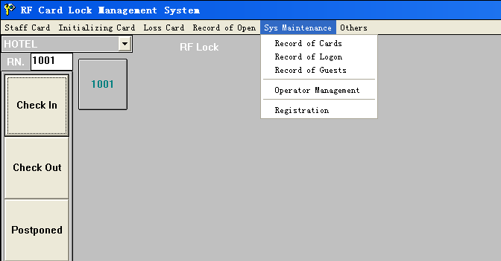
- Open The TXT file in the CD to get registration code and input it in the blank of New Register
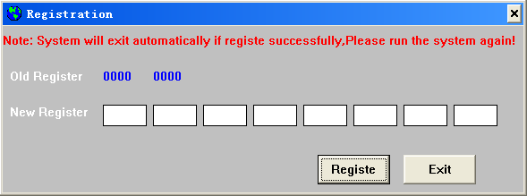
二、System login
After software running, the system will detect card reader of serial port, card reader will tweet when it was detected, then system log in to screen, see the figure 1. The first time log in ID is USER, no password, it has super management power(To protect the system, please add a new USER, and delete this superuser )
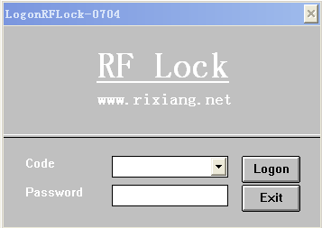
Figure 1

三、System main picture
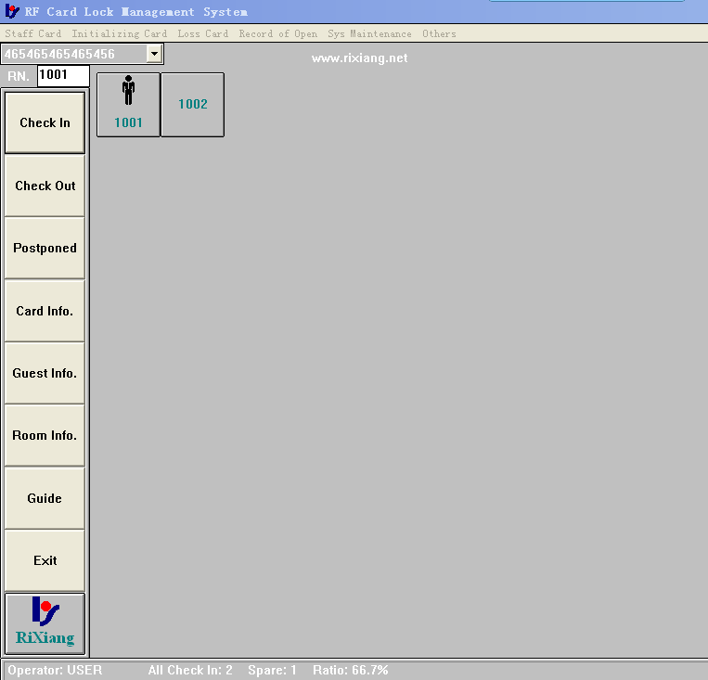
Figure 2
四、Operator management
（一）operator：
System can reset the operator’s purview according to the require
（二）operator management
- function：
·add、delete、reference operator information and right.
- Operation：
·Administrator’s User ID is “USER”, and it is not password, when use this system first. Choose “System Maintenance” and enter “Operator Management” ,as shown in figure 3.
·Add one operator，input the “Name” and “Code”, and choose the right first, and click[Add] button, new operator’s name as same as the password.
·Delete one operator, choose one user, and click [Delete] button.
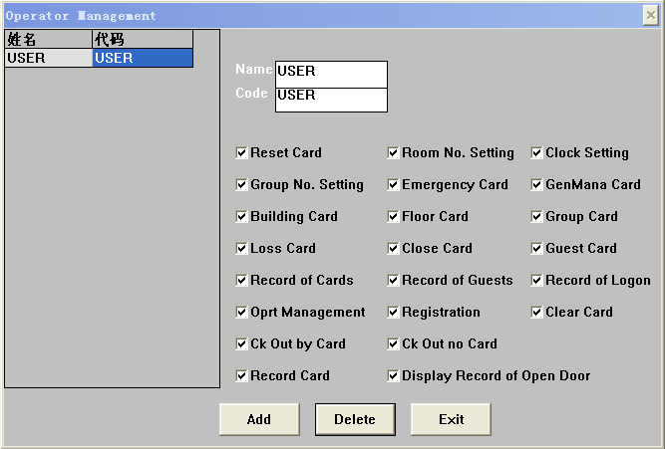
Figure 3
- Note:
·operator’s code should not be repeated。
·Add a operator, must be input the name and code.
五、Reset card
- Reset card：
Reset card is used all lock, and not time limit, suggestion issue one reset card.
（二）Write reset card：
Function：
·Issue the system reset card.
operation：
·choose “Initializing” and enter “Reset Card”；
3‚Note
·First run system, must be write a reset card, and using the card brush the all lock which the light LED ray is successful.
NOTICE:ALL OF THE LOCK CAN USE THE SAME ONE RESET CARD

六、Room NO. Setting Card
（一）Input room information：
1、function：
·Add rooms, delete rooms and write the room no. setting card.
- operation：
·Choose “Initializing” enter “Room No. Setting Card”, as shown figure 4.
·Add：input the room information, click [Add a room] button, if add successful, the room is add one auto.
·Delete：Input the Building No. and Room No., click [Del a room] button.
·Modify：Modify FloorNo. And RoomNo. of selected room.
RoomNo. must take 4 bits(Ex.0101 means FloorNo. is 1,RoomIndex is 01).
Modify FloorNo.:Click the FloorNo. You want to modify and click[Modi Room],the dialog as following picture will show up, input data and click [OK] to save and exit.
Modify Room ,Type and Rate is the same as Modify FloorNo.: select a data you want to modify and click [Modi Room]
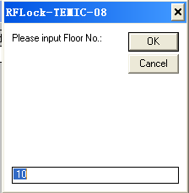
3‚Note
·First run system must be input room information, if not the operator not write guest card.
- Issue the room no. setting card：
Input the building no. and the room no., click [Room No. Setting Card] button. One card set a room.
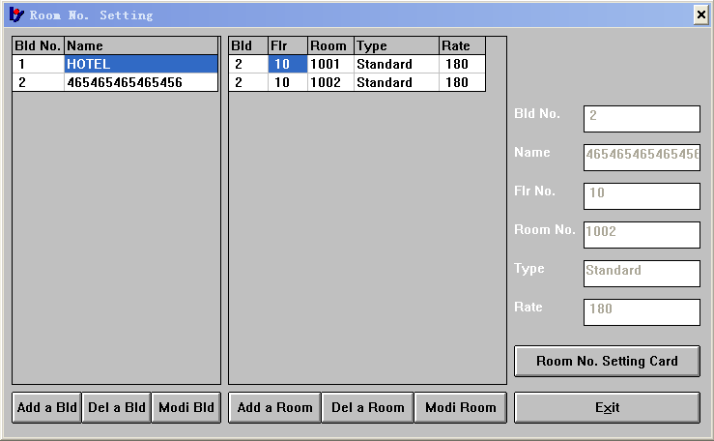
Figure 4
NOTICE: DIFFERENT LOCK MUST SET WITH DIFFERENT RoomNoSET CARD WITH DIFFERENT ROOMNO.

七、Clock Setting Card
- Function：
·Set the lock time as same as the computer.
- Operation：
·Choose “Initializing” enter “Clock Setting Card” as shown in figure 5.
- Note：
·Format time is year/month/day hource:minute;
·Set one floor lock every card.
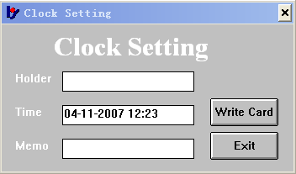
Figure 5
NOTICE:ALL OF THE LOCK IN ONE FLOOR CAN USE THE SAME ONE CLOCK SETTING CARD

八、Building Card
function：unlocking all the Lock in multi-storied building which haven’t been unlocked within appointed period of time
operation：Choose “Staff Card” enter “Building Card” as show in figure 6.

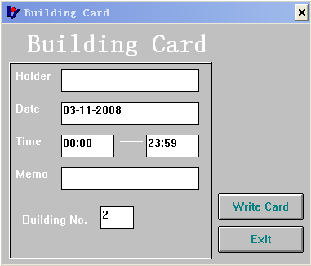
Figure 6

九、Floor Card
function：unlocking all the Lock in one or more multi-storied building which haven’t been unlocked within appointed period of time
Operation：Choose “Staff Card” enter “Floor Card” as show in figure 7.
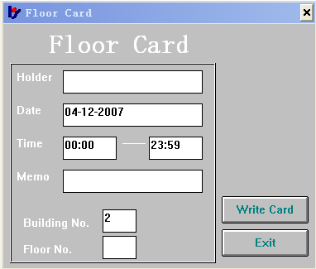
Figure 7

十、Guest Card
function：unlocking all the Lock in one house which haven’t been unlocked within appointed period of time. Operator can modify checkout time when needed before write card.

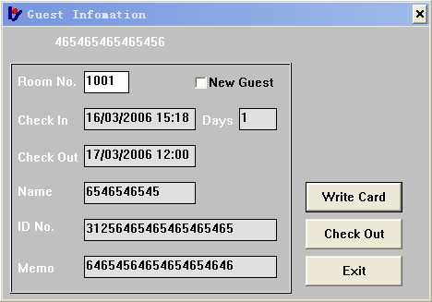
Figure 8

十一、Records of Open Door
- function：Query the one lock’s records of open the door.
- Operation：
·Choose “Record of Open Door” enter “Record Card”, and Write a Card.
·Using the “Record Card” brush the lock, the blue light is ray.
·put on the record reader’s power 3s after. Put the record reader to the front of the lock .
·the record reader buzzer a sound, and the blue light ray all time. The lock’s blue light ray every 1s.
·end, the lock and record reader all buzzer one sound. This time is 50s.
·close the record reader. And connet the record reader to gether with computer’s seril.
·Open the record reader’s power, choose “Records of Open Door” , and enter the “Display the Record”.
·click [read] button.
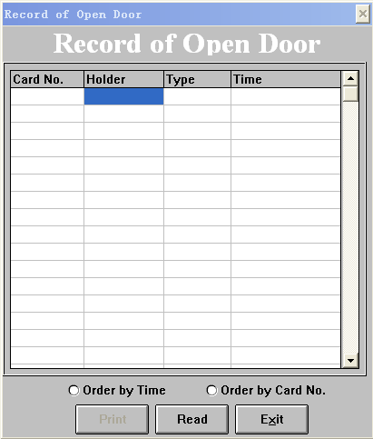
Figure 9

十二、Other function
Emergency Card
Emergency Card can open all lock of the system. And it is not time limit.
二、Master Card：
Emergency Card can open all lock of the system. And it is not time limit.
三、Multi Card：
We can issue a Multi Card,if one of the houses need to lock ,due to the special reason.Put it on the Lock, Green light will shine together with the sound ,it shows the lock was locked.All the Card can not open it ,but all the key the will not be affected ,And only the authorized card can relieve it.
四、Loss Card：
We can isse a loss card when one of the card is lost. Using the loss card brush the lock, you can hear a sound and see the blue LED light ray, the loss card loss successful. But if lost the “Master Card “ or “Emergency Card”, the loss card should brush the all lock. If lost the “Building Card”, the loss card should brush the Building’s lock. If lost the “Floor Card”, the loss card should brush the All lock of the Floor.
五、Clear Card：
If the card is not use, we clear it. After clear, the card used other function card. If you card if a clock card or room no. setting card, or loss card, or group setting card, you must be clear the card right now.
六、Password Change：
Every operator Can change the password.
七、Query Records：
Query/Delete the operator’s login records, Write card records and guest records, act.

